Enabling use of OpenMP with Visual Studio

Create a new project containing the code:

#include <omp.h>

#include <stdio.h>

int main() {

#pragma omp parallel

printf("Hello from thread %d, nthreads %d\n",

omp_get_thread_num(), omp_get_num_threads());

printf("Press Enter To Continue");

getchar();

}

Building and running this should give:  
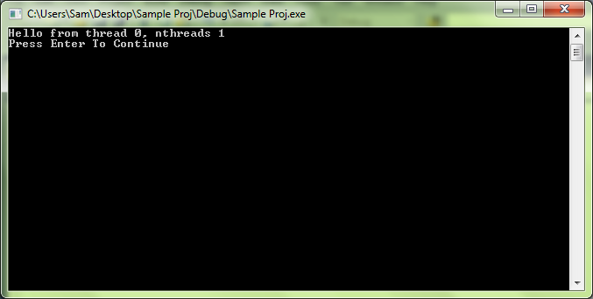

Right click on the current Project and select “Properties”:  
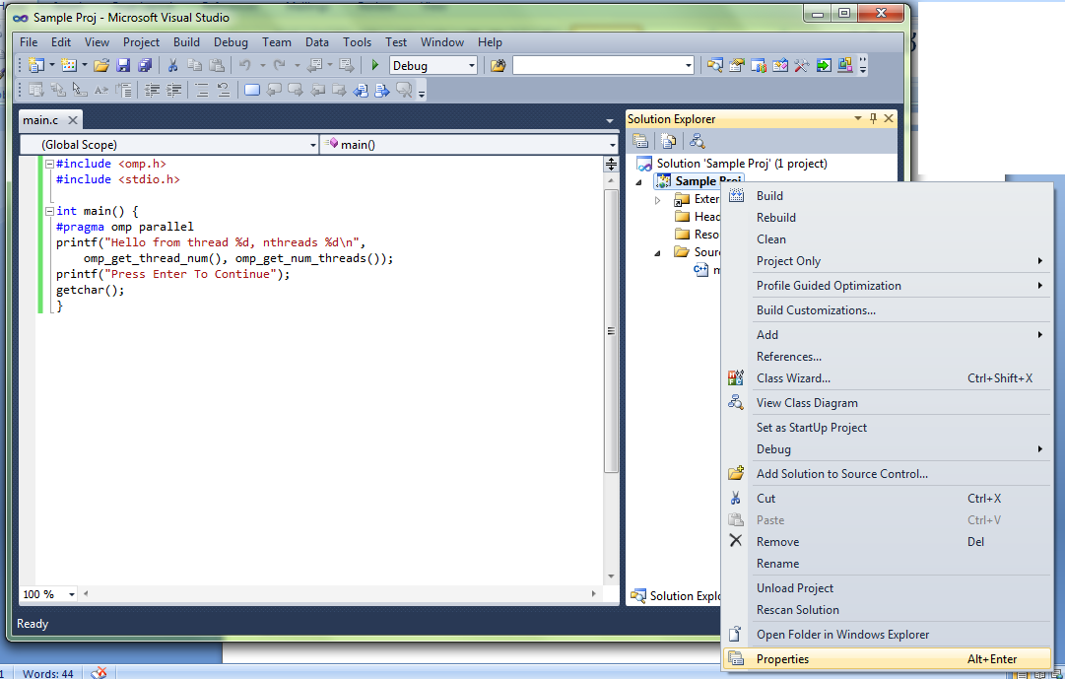

Navigate down the TreeView on the left of the window. Configuration Properties -> C/C++ -> Language.  
Find OpenMP Support and set this to “Yes (/openmp)”.

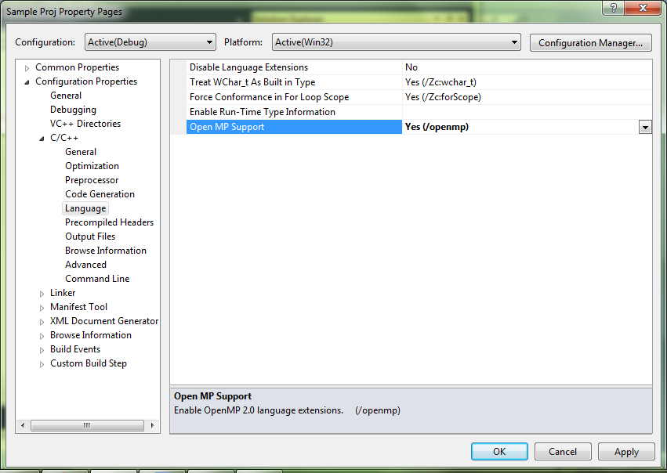

Now re-build and run the project and – assuming you have a multi-processor machine – the output should be different.

